(Effective Alternative Secondary Education)

CHEMISTRY

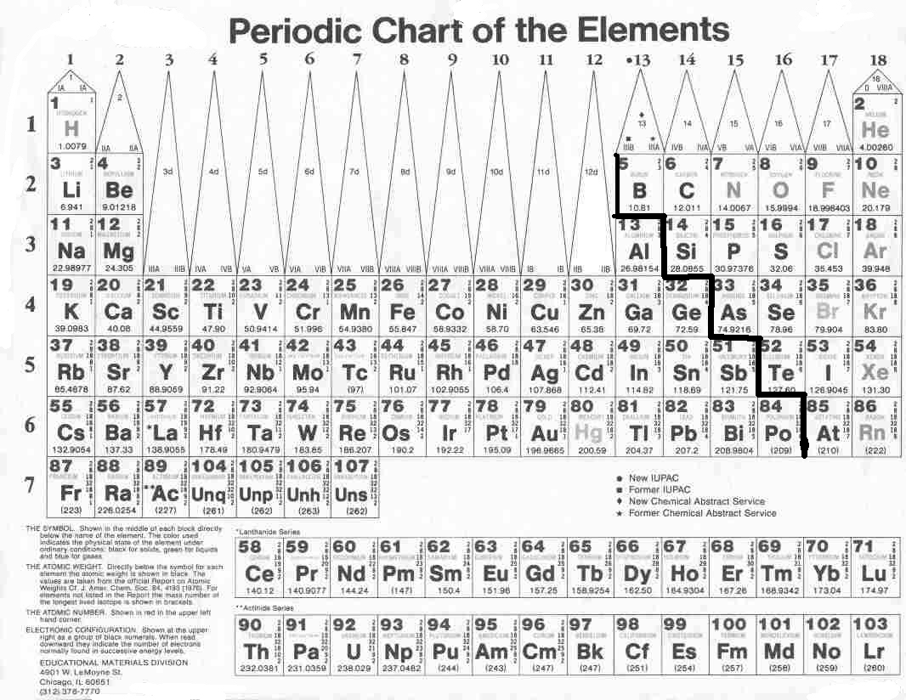
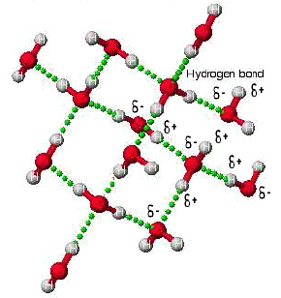

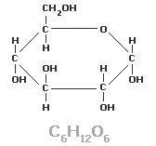
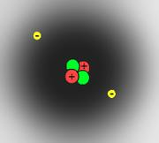

MODULE 8

Behavior of Gases


BUREAU OF SECONDARY EDUCATION
Department of Education
DepEd Complex, Meralco Avenue

Pasig City

Module 8
Behavior of Gases

What this module is about

This module will require a lot of your imagination because many gases are colorless, unlike solids and liquids that are visible. For instance, you need to visualize the molecular motion of particles in the gas phase of matter as if there’s a group of people in chaos inside a burning house.

The kinetic molecular theory of gases is an attempt to explain the behavior of the particles of gases such as its rate of motion, the distances between its particles and the force that exists between the gas molecules. It highlights the differences in the property of the three (3) phases of matter namely: solid, liquid and gas. The fourth phase of matter, plasma, is not considered in the discussion because it exists only in extreme temperature and pressure. The conditions considered in this module are those that exist within the range of normal temperature and pressure.

The module contains the following lessons:

- Lesson 1 – Kinetic Molecular Theory of Gases
- Lesson 2 – Diffusion and Effusion Rates of Gases
- Lesson 3 – Practical Applications of Behavior of Gases


What you are expected to learn

After going through this module, you should be able to:

- state and illustrate the kinetic molecular theory of gas;
- differentiate diffusion and effusion of gases;
- state the relation of rate of diffusion and effusion to the molecular mass of gas substance; and
- cite some practical applications of the behavior of gases.

How to learn from this module

Take enough time to read and study each lesson in this module. It is a must that you read it with understanding and with the help of a dictionary, if necessary. Perform the activities diligently as these will deepen your conceptual understanding of the lessons.

Just be honest in evaluating yourself in the self-test portion of this module. Try hard to answer the test without looking back at the lecture. Go over the lesson again if you fail to get at least 70% of the items in the test.

What to do before (Pretest)

Multiple Choice: Choose the letter of the best answer. Write the chosen letter on a separate sheet of paper.

- Which of the following best describes the molecules of a gas?
- All the molecules are connected by bending and stretching.
- The molecules are not connected and are moving very rapidly.
- The molecules are arranged in strings and are moving very rapidly.
- The molecules are not connected and are moving slowly by bending and stretching.

- All of these are properties of gases EXCEPT
- can conduct electricity
- can be compressed easily
- can move from one place to another randomly
- can expand when the temperature is increased by increasing the distances between molecules.

- This scientist formulated the law of diffusion and effusion of gases. Who was he?
- John Dalton c. Thomas Graham
- Robert Boyle d. Jacque Charles

- Which among these gases contributes primarily to air pollution?
- H₂ c. CO₂
- CO d. NO₂

- Which among these substances will diffuse fastest?
- HCl c. CO₂
- NH₃ d. NO₂

- A gas confined in a closed container is heated. What will happen to the gas?
- The gas molecules move faster.
- The gas molecules settle to the bottom of the container.
- The gas molecules collide with each other less frequently.
- The gas molecules collide with the wall of the container less frequently.

- All of the following proves that gas diffuses EXCEPT
- Toxic chemicals in cigarette smoke spread in a car.
- The sweet fragrance of perfume spreads in a room.
- The aroma of the coffee is confined in one corner of the room.
- The CFC from aerosol spray reaches the upper atmosphere and destroys the ozone layer.

- As gas molecules collide, which will not happen?
- They stick together. c. Their kinetic energies are conserved.
- They gain their kinetic energies. d. They will explode.

- Which of the following gases is a product of incomplete combustion in automobile engine?
- CH₄ c. CO₂
- CO d. NO₂

- The following statements illustrate the kinetic theory of gases EXCEPT
- The gas molecules move slowly in all direction.
- The distances between gas molecules are negligible.
- The gas molecules do not interact except during collisions.
- The gas molecules often collide with each other or with their container.

Key to answers on page 17.

Lesson 1. Kinetic Molecular Theory of Gases
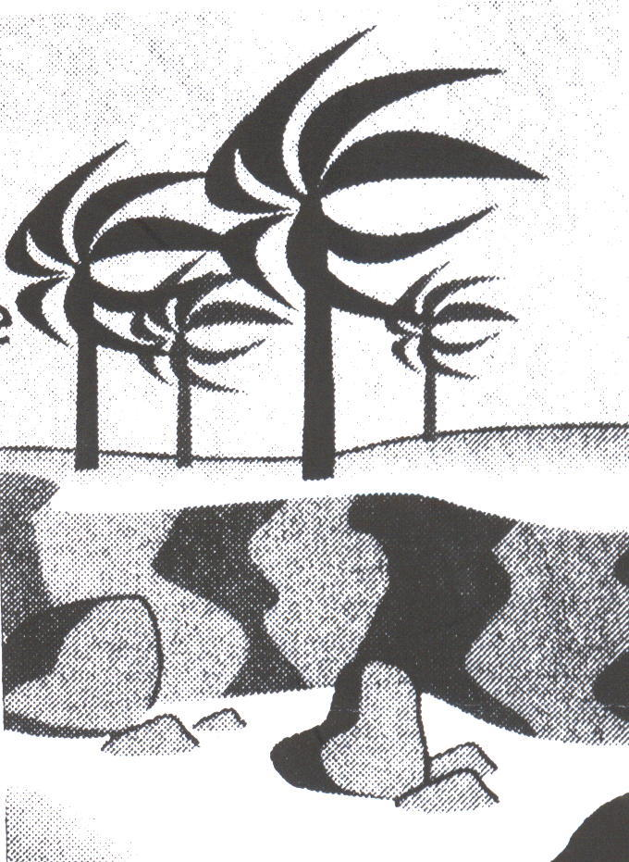

The word “gas” seems to mean different things to various people. Some think that it refers to the ‘gas’ that we use for cooking and heating. Others think that ‘gas’ is the fuel for automobiles and industrial machines.

So, what is meant by gas? Gas is found everywhere. It enters our body everyday every time we inhale and exhale. Do you know that almost 16 kg of gases get into our lungs everyday? Every time we use perfume spray or aerosol spray, we encounter gases. Inflating a balloon and opening a refrigerator are examples of gas in pressure.

What you will do

Activity 1.1 Properties of Gases
plastic ice bag
rubber band
soft drinks can

Materials: empty soft drinks can
plastic ice bag
rubber band
alcohol burner

Procedure: (Refer to the diagram for the assembly.)

- Put the plastic ice bag on the top edge of the empty soft drinks can.
- Tie the plastic with rubber band. See to it that no air escapes the system.
- Heat the bottom part of the can. Observe what happens.
______________________________________________________________________

- Remove the burner and let it cool. What happens to the plastic ice bag?
______________________________________________________________________
Key to answers on page 18.

You’re right in your observations! Why?

This activity illustrates that gases exhibit expansibility and compressibility. Expansibility is the property of gases to increase the spaces between its molecules if the temperature is increased. Compressibility is its ability to compress if the temperature is decreased.

Another property of gases is its ability to diffuse or intermingle with the molecules of other substances. This property is called diffusibility. When your mother is cooking “bagoong”, what do you observe? You can smell the cooked bagoong with sauted garlic at a distance, right? This is because the molecules of the sauted garlic in bagoong mingled with the molecules of the air. This phenomenon can be further explained by the kinetic theory of gases.

What is the Kinetic Theory of Gases?

In the 18th century, a Flemish scientist and Physicist named Jan Baptista Van Helmont was the first to use the word “gas”. He derived the term from the Greek word “chaos”, which means formless mass. He felt that gases were a disordered, formless type of matter and can be found anywhere.

The properties and characteristics of gases can clearly be explained by a series of statements called the Kinetic Theory of Gases. This theory states that:

- gases consist of independent molecules at normal temperature. The distance between gas molecules are so great compared to the size of the molecule itself.
- gas molecules do not interact except during collisions. The force of interaction between molecules is almost negligible.
- gas molecules move rapidly, randomly and constantly in any direction.
- gas molecules often collide with each other or with their container. The collision of gas molecules is completely translational.
- When the temperature increases, gas molecules move faster. When the temperature decreases, the gas molecules move more slowly. The kinetic energy of the molecules of gas is directly proportional to its absolute temperature.

The fourth property of gases is its ability to move rapidly and randomly because it has low density. The movement of gases is dependent to its molecular mass. Helium, He₂ gas having a molecular mass of 8 g/mol (2 x 4 g/mol) travel faster than a chlorine gas, Cl₂, with a molecular mass of 70 g/mol (2 x 35 g/mol). This is why helium gas is used to inflate balloons.

What you will do

Self-Test 1.1 Kinetic Theory of Gases

Fill in the blanks to complete the statements of the Kinetic Theory of Gases.

- Gases consist of ____________molecules.
- At normal atmospheric pressure and standard temperature, the distances between gas molecules are ___________.
- Gas molecules do not interact except during _____________.
- The ___________ between gas molecules is almost negligible.
- Gas molecules move rapidly, ______________, and constantly in any direction.
- Gas molecules are always in ____________.
- Gas molecules often collide with other gas molecules or with their container. The collisions are completely _______________.
- When the temperature ________, gas molecules move faster. When the temperature _______, gas molecules move more slowly.
- The average _______________ of gas molecules is directly proportional to the absolute temperature of the gas.
- The ability of gases to intermingle with the molecules of other substances is called _________________.
Key to answers on page 18.

Lesson 2. Diffusion and Effusion of Gases

If someone opens a bottle of perfume at one end of a room, a person at the other end of the room soon smells the scent of the perfume. Why? The vapors from the perfume mix with the air inside the room and spread out evenly and slowly throughout the room. This is a direct demonstration of the random motion of vapor molecules of the perfume, which is provided by diffusion. So what is diffusion? Diffusion is the gradual mixing of the molecules of one gas with the molecules of another gas because of their kinetic energies.

The diffusion process takes a relatively long period of time to complete. It will take some time before a person at the other end of the room can smell the perfume scent. Why is that so? You see, the molecules of a perfume experience numerous collisions with the other air molecules in the room while moving from one end of the room to the other.

Diffusion of gases always happens gradually, and not instantly as molecular speeds seem to suggest. Furthermore, since the average speed of light gas molecules is greater than the average speed of heavier gas molecules, a lighter gas will diffuse through a certain space faster than a heavier one. How do gas molecules pass through a small tiny opening or pinhole of a container?

If a gas container has a tiny opening, gas molecules inside the container gradually escape from the container. Since gas molecules are in constant motion, they randomly strike the tiny opening and pass through the pinholes. This behavior of gas is called effusion.

Effusion can be utilized to determine the leakage of a certain gas container like the L.P.G. tank that we use in cooking.

In 1829, a Scottish chemist named Thomas Graham experimented with the diffusion and effusion of gases. He discovered that gas molecules with high velocity diffuse or effuse faster than molecules with low velocity. But what determines the velocity of gas molecules?

Graham also discovered that when the temperature and pressure of gases are equal, their velocities are determined by the mass of their particles. He proposed the Graham’s law of diffusion /effusion as follows:

Under conditions of equal temperature and pressure, the rates of effusion or diffusion of two gases are inversely proportional to the square roots of their molar masses

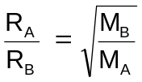 | Where: R_{A} = rate of effusion/diffusion of gas A  R_{B} = rate of effusion/diffusion of gas B  M_{A} = molar mass of gas A  M_{B} = molar mass of gas B

In fact, according to the Kinetic Molecular Theory of gases, the temperature of a gas directly affects the kinetic energy of its molecules.

At constant temperature and pressure, the kinetic energies of gases are the same and from the definition of kinetic energy we have,

KE_{A} = KE_{B}

½ M_{A}R_{A}² = ½ M_{B} R_{B}²

canceling the common ½ on both sides of the equations and regrouping the
variables;

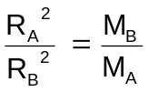

Simplifying,

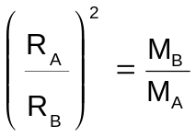

Getting the square root of both sides of the equations:

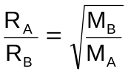

Put simply, Graham’s law of diffusion/effusion assumes that gas particles with a lower molar mass (lighter one) diffuse or effuse faster than those having high molar mass (heavier gas).

Application of Graham’s Law of Diffusion/Effusion of Gases:

At 25⁰C, the average speed of oxygen molecule is 482 m/s. Find the average speed of a hydrogen molecule at the same temperature. Which gas will diffuse faster using the relationship of relative rates of diffusion of gases to their molar masses? We know that H₂ has 2g/mole and O₂ has 32g/mole. Since H₂ has a lighter molar mass, does it mean that H₂ will diffuse faster?

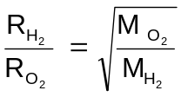

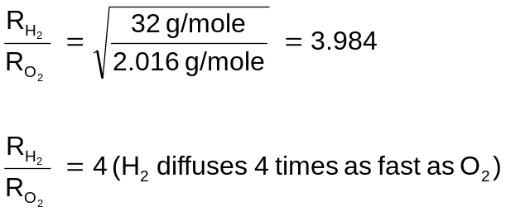

Solving for the rate of diffusion of H₂ if rate of diffusion of O₂ is 482 m/s;

Furthermore, based on the definition of rate of motion of gas particles (rate of effusion/diffusion) and the distance traveled by gas molecules per unit time (R=d/t), Graham’s law of diffusion/effusion can be simplified as:

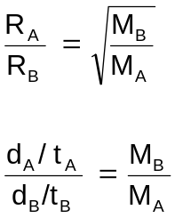

If the distance traveled by the 2 gases are the same; d_{A} = d_{B}

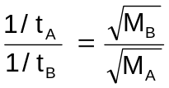

Furthermore

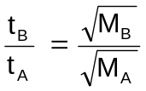

Where: t_{B} = time it takes for gas A to diffuse/ effuse the same distance as gas B
t_{A} = time it takes for gas B to diffuse/ effuse the same distance as gas A

Do you know that you can identify the molar mass of an unknown gas by using the relationship of time of effusion / diffusion of gases to their molar masses?

Suppose that an experiment on effusion is performed to identify the molar mass of an unknown gas. It requires 45 seconds for a certain amount of an unknown gas to pass through a pinhole into a vacuum under the same condition. On the other hand, it only takes 26 seconds for the same amount of Argon (Ar) to effuse. With the given values, find the molar mass of the unknown gas.
Use the relation of time of effusion and molar mass of gases:

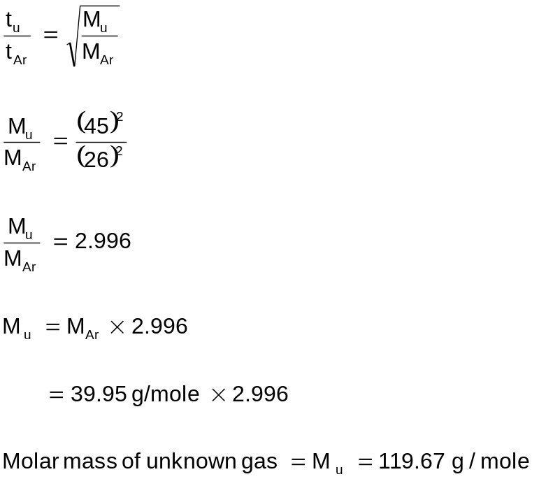

What you will do
Activity 2.1 Problem Solving in Graham’s law

- Helium gas (a gas that enables the balloon to float in air) effuses 2.0 times faster than another gas. What is the molar mass of the other gas?

- Which of the following is most likely to be the unknown gas in problem no. 1?
- CH₄ c. CO₂
- NO₂ d. NH₄
Key to answers on page 18.

Lesson 3. Practical Application of the Behavior of Gases

Learning the behavior of gases based from its properties such as diffusibility, compressibility, expansibility and low density, this lesson enables us to see the application of the said behavior in our daily life.

Do you know that altering the surface of the earth by covering it with concrete, asphalt and metal structures causes tremendous change in our atmosphere? Radiant energy of the sun in the form of heat reaches the earth’s surface and is reflected back by the concrete and asphalt covering of the earth. The reflected heat is absorbed by the air particles causing them to become more mobile thus circulating hot air in our land.

This is proven by one of our postulates in kinetic molecular theory of gases which states that absolute temperature of gas substances is directly proportional to its average translational kinetic energy. Likewise, the increase in the kinetic energy of gas particles increases the diffusion rate of even the polluted gases in the air.
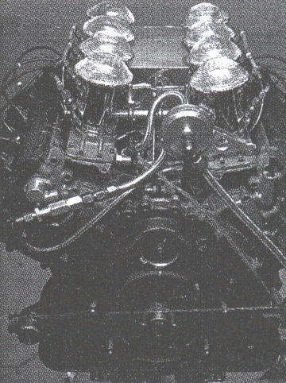

Figure 3.1
When a fuel is burned in the cylinder of a machine, it produces the gaseous product of combustion like CO₂, H₂O and sometimes CO and unburned fuel, if the combustion is incomplete.

What you will do

Activity 3.1 Paper Turbine (Expansion and Convection of Air)

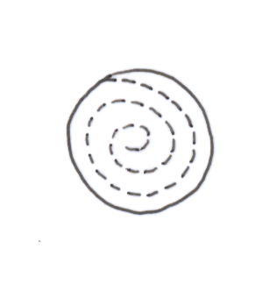

Materials: Paper or Cardboard Match
Figure A
Figure B
Small Burner Stick
Scissor Thread

Procedure:

- Cut a circle from a piece of cardboard. Cut it further spirally. (Figure A)
- Tie a thread to the center of the spiral and suspend it above the flame of a burner. (Be careful not to burn it). (Figure B)
- What happened to the spiral board?
______________________________________________________________________
- Lift the spiral board up and down over the flame.
a. What do you notice? ________________________________________________
b. Why? ____________________________________________________________

Through this experiment we can create a simple turbine. We all know that a “steam turbine” operates with the use of vapor from boiling water, but this time we will make the paper spiral spin with the use of convection current of the hot air coming from the flame. The lighted lamp produces heat, which heats up the particles of the air around it. The air particles that gets heated expands, therefore decreasing its density. In a mixture of warm and cold air, the warm air will rise forcing the cold air downward. Then the convection current in air occurs, which makes the spiral spin.

In cooking, particularly in tenderizing meat faster, a pressure cooker is used. The increase in pressure is due to the air trapped in the cooking device through the accumulation of steam. This delays the boiling point of the liquid in the pressure cooker, which in turn allows it to boil at a temperature higher than 100ºC. Thus, the food absorbs more heat causing it to become soft quickly.

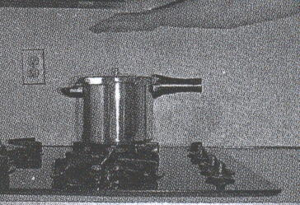
Figure 3.2
Pressure cooker increases the boiling point of the water solution in it by building up the pressure of the air trapped from the evaporated steam in the cooking device.

Another technology that uses the principle of air convection is the exhaust fan. An exhaust fan should be placed at the higher portions of the wall in order to maximize its purpose. It aims to release hot air from a kitchen for proper ventilation. From the properties of gases, light dense gas like hot air floats and more dense gas like cold air sinks. As hotter gases float in the air, the fan causes the colder air to circulate in the room by sucking hot air out of the room.

The inflation of the tire with air keeps its shape round. Air in the tires allows the vehicle to make a turn along a sharp curve without being deformed. It cushions the ride of the passengers, especially when the car is passing through rough roads or pavements.
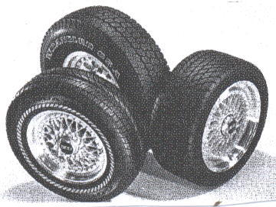

Figure 3.3
The pressure of the air inside the tire causes it to be always in good shape for a comfortable ride.

The differences in the densities of gases like those between air and helium enable the production of a weather balloon. Helium, which is less dense than air, is commonly used to inflate weather balloons. These types of balloons are used mainly in the measurement and evaluation of upper atmospheric conditions. Weather information may be gathered during the vertical ascent of the balloon through the atmosphere or during its motions once it has reached a maximum altitude, which is predetermined. Atmospheric pressure, temperature, and humidity information may be sent by radio from a balloon. Monitoring of its movement provides information about winds at its flight level.
Figure 3.4
A weather balloon in flight

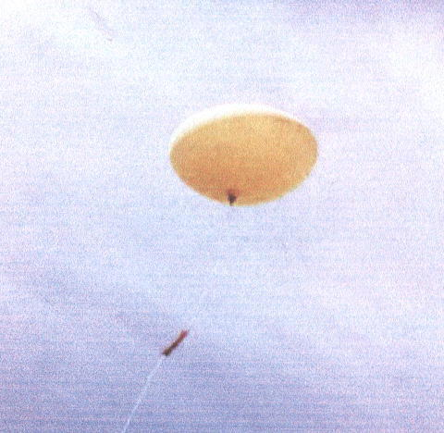

Gases are also involved in atmospheric pollution. Numerous invisible cycles of nature happen in our surrounding everyday. Majority of these cycles involve gaseous substances. They even change our climate naturally. A tremendous change in our climate occurred since the start of the industrial revolution in the 18th century. The changing agricultural and industrial practices in the industrial revolution began altering our climate and environment.

Before the industrial revolution, human activity releases very few gases into the atmosphere, but now because of population growth, fossil fuel burning and deforestation, we are affecting the mixture of gases in the atmosphere. Carbon dioxide (CO₂) is released to the atmosphere when solid waste like garbage, fossil fuel such as oil, natural gas and coal are burned.

Don’t you know that every 1-gram of fossil fuel burned releases about 3 grams of CO₂ into the atmosphere? Plants in photosynthesis use parts of this CO₂, but deforestation lessens the accumulation of CO₂.

Human activity has altered the chemical composition of the atmosphere through the build up of greenhouse gases primarily carbon dioxide (CO₂), methane (CH₄) and nitrous oxide. These gases together with water vapor create the natural greenhouse effect. The ability of these gases to absorb infrared radiation (heat) warms the earth. In this way, CO₂ and H₂O act as an insulating blanket to prevent heat from escaping into outer space, which is often referred to as the greenhouse effect.

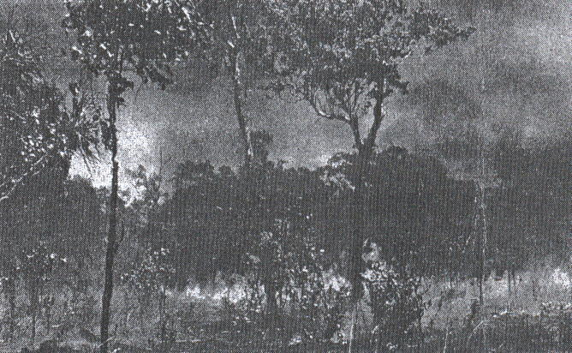

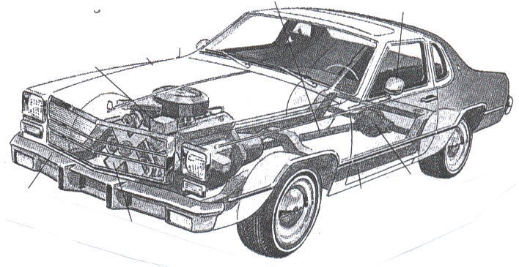
(a)
Exhaust gas of automobile contributes to air pollution
(b)
Deforestation and burning of forests lessen the users of polluted gas, CO₂

Figure 5. Causes of air pollution

What you will do

Self-Test 3.1

From the behavior and properties of gases, identify what principle is involved in each situation:

- People are warned not to dispose empty aerosols or spray cans in an incinerator or flame because these might explode.
- The volume of the floating balloon in the air increases as it ascends upward.
- A basketball player trained at sea level experiences hardship of breathing during the first few hours of playing in an elevated place like Baguio.
- Food is cooked in a shorter time using the pressure cooker.
- It is advisable not to increase the tire pressure to its full limit when driving during summertime.
Key to answers on page 18.

Let‘s Summarize

You have learned that:

- According to Jan Baptiste Van Helmont, gases are a disordered, formless type of matter.

- The kinetic molecular theory (KMT) of gases describes the behavior of molecules of gases. Through the KMT of gases, we can explain logically what happens at the molecular level that results to the changes that we observe in the macroscopic level.

- The Kinetic Molecular Theory of gases is based on the following assumptions:
- gas molecules are separated by distances bigger than their own dimensions, in which we can consider the total volume of the gas molecules to be negligible,
- they are in constant motion and they frequently collide with one another and with the walls of the container without losing their kinetic energy,
- the molecules neither attract nor repel one another.

- The forces of attraction between liquid and solid molecules are much greater than those between gas molecules. As a result, the molecules of a liquid are very close to each other giving the liquid a definite volume but no specific shape.

- The particles of a solid are close together and are held in a fixed position resulting to the definite volume of solid.

- Diffusion is the gradual mixing of two gases due to the spontaneous random movement of gas particles while effusion is the behavior of gas particles to pass through a very small opening of its container.

- Graham’s law of diffusion/effusion states that at a constant temperature and pressure, the rates of effusion or diffusion of two gases are inversely proportional to the square roots of their molar masses.

Posttest

Multiple Choice. Choose the letter of the best answer. Write the chosen letter on a separate sheet of paper.

- A gas confined in a closed container is cooled. Which of the following does NOT happen to the gas?
- The gas molecules move slower.
- The gas molecules collide with the wall of the container less frequently.
- The gas molecules settle to the bottom of the container.
- The gas molecules collide with each other less frequently.

- As gas molecules collide, what happens?
- They stick together. c. Their kinetic energies are conserved.
- They lose their kinetic energies. d. They will explode.

- The gradual mixing of two gases due to the spontaneous, random motion of the gas particles is called
- effusion c. diffusion
- cohesion d. viscosity

- Which property shows that gas molecules are always moving?
- Have a high density c. Have a high rate of diffusion /effusion
- Easily compressible d. Have a definite shape and volume

- Which of the following proves that gas diffuses?
- Toxic chemicals in cigarette smoke spread in a car.
- The sweet fragrance of perfume spreads in a room.
- The CFC from aerosol spray reaches the upper atmosphere and destroys the ozone layer.
- All of the above

- Which statement about gas is NOT true?
- It is incompressible.
- It expands when heated.
- It has lesser density than solid and liquid.
- It has no definite shape but has definite volume.

- When air is added into an automobile tire, which of the following does NOT happen?
- The gas density increases.
- The gas molecules move faster.
- The gas molecules collide more frequently.
- The space between the molecules decreases.

- The diffusion process of a gas takes a relatively long period of time to complete because ____________________.
- gas molecules are very near each other.
- gas molecules are crowded because of high density.
- gas molecules have a relatively low average kinetic energy.
- gas molecules experience numerous collisions while diffusing.

- According to Graham’s law of diffusion, the rates of diffusion of gases are ___________ to the square roots of their molar masses .
- not directly related
- directly proportional
- inversely proportional
- related squarely proportional

- The average kinetic energy of gas molecules is measured by their ___________.
- pressure c. volume
- temperature d. density

II. From the behavior and properties of gases, identify what principle is involved in each situation:

- It is advisable not to remove the tab of a can of a warm soft drink after shaking it vigorously.
- Fully inflated balloons should not be exposed to extreme heat like sunlight because it might explode.
- The freshness of flowers reaches our nose.
- Helium gas is used to inflate balloons.
- The light of a candle will be extinguished when it is placed under an inverted jar or bottle.
Key to answers on page 19.

Key to Answers

Pretest

1. c | 6. a
2. a | 7. c
3. c | 8. a
4. b | 9. b
5. b | 10. a

Lesson 1

Activity 1.1

3. The plastic blew-up.
4. The plastic bag returned to its original size and shape.

Self-Test 1.1

1. independent | 6. motion
2. great or large | 7. elastic
3. collision | 8. rises ; lowers
4. force of attraction | 9. kinetic energy ; directly
5. randomly | 10. diffusibility

Lesson 2

Activity 2.1

- M_{HC} = 4 g /mole R_{He} = 2R_{U}
M_{U} = ?

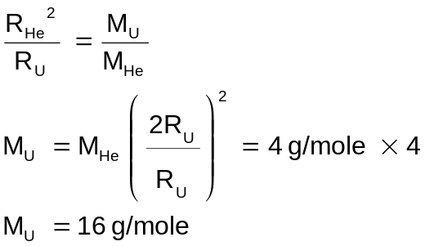

- (a) CH₄

Lesson 3

Self-Test 3.1

- expansibility
- expansibility
- compressibility
- expansibility
- expansibility

Posttest

I. |  | II.
1. c | 6. d | 1. expansibility
2. c | 7. b | 2. expansibility
3. c | 8. d | 3. diffusibility
4. c | 9. c | 4. low-density
5. d | 10. b | 5. compressibilty

References

Books:

Araneta, F.L., Catris, L.V. & Deauna, M.C. (2002). The world of chemistry III. (2nd ed.) Quezon City: SIBS Publishing House, Inc.

Chang, R. (2005). Chemistry. (8th ed.) New York: Mc Graw-Hill Companies.

Magno, M.C., Tan, M.C. & Punzalan, A.G. (2000). Science and technology for a better life (3rd ed.) Manila: Diwa Scholastic Press Inc.

Masterton, W.L. & Hurley, C.N. (1993). Chemistry principles and reactions. (2nd ed.) USA: Saunders College Publishing.

Regalado, E.C. (2001). Chemistry. Manila: St. Augustine Publications,Inc.

Sherman, S.J. & Sherman, A. (1999). Essential concepts of chemistry. New York: Houghton Muffin Company.

